**Synopsis**

**On**

**Face Monitoring System for Safety Measures**

**Submitted in partial fulfilment of the requirement**

**For the award of the degree**

**Of**

**B. TECH**

**In**

**Computer Science & Engineering**

**Submitted By**

**Tushit Agarwal (1606810342)**

**Tavishi Gupta (1606810336)**

**Sparsh Gupta (1606810324)**

**Sidharth Jain (1606810321)**

**Under the guidance**

**Mr. Vishal Jayaswal**



**Department of Computer Science & Engineering**

**Meerut Institute of Engineering & Technology, Meerut**

**Problem Statement:**

In recent years driver’s dizziness is one of the major causes of vehicle accidents in the world. One best way of measuring driver drowsiness is measuring the state of the driver i.e. drowsiness. So, it is very important to detect the drowsiness of the help driver to save life and property. This project is aimed towards developing a prototype of a face monitoring system that will help in detecting the drowsiness of the driver. This system is a real time system which captures image continuously and measures the state of the eye according to the specified algorithm and gives warning if required.

**Why is the particular topic chosen?**

Driver fatigue is a significant factor in a large number of road accidents. Recent statistics estimate that annually 1,200 deaths and 76,000 injuries can be attributed to fatigue related crashes. In the past years according to available data driver sleepiness has gotten to be one of the real reasons for street mishaps prompting unfortunate demise, extreme physical injuries and loss of economy. A driver who falls asleep is in an edge of losing control over the vehicle resulting into crash with other vehicle or stationary bodies. Keeping in mind to stop or reduce the number of accidents to a great extent the condition of sleepiness of the driver should be observed continuously.

The development of technologies for detecting or preventing drowsiness at the wheel is a major challenge in the field of accident avoidance systems. Because of the hazardous situation that drowsiness presents on the road, methods need to be developed for counteracting its effects.

The aim of this project is to develop a prototype drowsiness detection system with the help of face monitoring. The focus will be placed on designing a system that will accurately monitor the open or closed state of the driver’s eyes along with the face in real-time.

By monitoring the eyes, it is believed that the symptoms of driver’s fatigue can be detected early enough to avoid a road accident. Detection of fatigue involves the observation of eye movements and blink patterns in a sequence of images of a face.

**Objectives and Scopes:**

* Our objective of the project is to ensure the safety system.
* Driver drowsiness is recognized as an important factor in vehicle accidents.
* The main objective is to first design a system to detect driver’s drowsiness by continuously monitoring the retina of the eye.
* The system works in spite of drivers wearing spectacles and in various lighting conditions.
* To alert the driver on the detection of drowsiness by using a buzzer or alarm.  Speed of the vehicle can be reduced.  Traffic management can be maintained by reducing the accidents
* Our system has a wide scope further. It can be directly integrated with any hardware system like Arduino to extend the functionality of the system.
* It can be used in the system where high surveillance and monitoring is required with addition of high accuracy.
* Security alerts where 24*7 security is required, medical examining, online examination monitoring, hassle free driving are some other aspects where it can be moulded to make a better use of it.

**Methodology:**

This chapter deals initially with object detection. Because face is also a type of object, hence how the detection of objects is done using OpenCv is described. Next it deals with face detection techniques based on object detection. Though several class of objects can be identified using object detection technique but for our purpose only face detection will be used. Next part of this chapter focuses on eye detection technique as it is the most important stage drowsiness detection and also the next step of measurement of state of eye strongly depends on this.

This approach will be mostly focusing on amount of eye closure also called (PERCLOS) percentage of closure as it provides the most accurate information on drowsiness. It is also non-intrusive in nature, hence does not affect the state of the driver and also the driver feels totally comfortable with this system. Environmental factors like road condition does not affect this system. The case of micro nap is also detected according to the given threshold value. The development of this system includes face identification and tracking, detection and location of the human eye, human eye tracking, eye state detection, and driver fatigue testing. The key parts of the detection framework fused the detection and location of human eyes and driver fatigue testing. The improved technique for measuring the PERCLOS estimation of the driver was to compute the proportion of the eyes being open and shut with the aggregate number of frames for a given period.

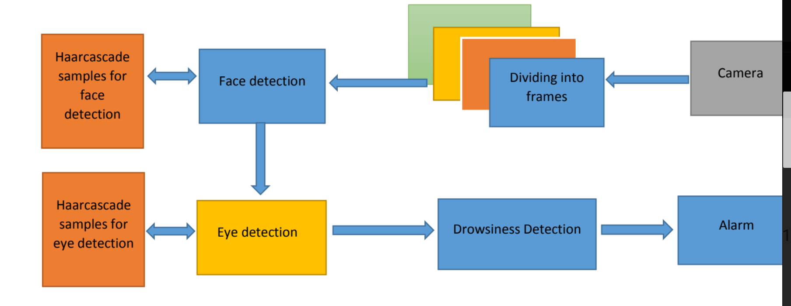

**Fig.1 Figure showing entire process of Face Monitoring System**

**Process Description:**

**Image Capture:**

Utilizing a web camera introduced inside the automobile we can get the picture of the driver. Despite the fact that the camera creates a video clip, we have to apply the developed algorithm on each edge of the video stream.

**Dividing into Frames:**

We are dealing with real time situation where video is recorded and has to be processed. But the processing or application of algorithm can be done only on an image. Hence the captured video has to be divided into frames for analysing.

**Face Detection:**

In this stage we detect the region containing the face of the driver. A specified algorithm is for detection of face in every frame. By face detection we mean that locating the face in a frame or in other words finding location of facial characters through a type of technology with the use of computer. The frame may be any random frame. Only facial related structures or features are detected and all others types of objects like buildings, tree, bodies are ignored.

**Eye Detection:**

After successful detection of face eye needs to be detected for further processing. In our method eye is the decision parameter for finding the state of the driver. Though detection the eye may be easier to locate, but it’s really quite complicated. At this point it performs the detection of eye in the required particular region with the use of detection of several features. Generally, Eigen approach is used for this process. It is a time taking process. When eye detection is done then the result is matched with the reference or threshold value for deciding the state of the driver.

**State of eye:**

In this stage, we find the actual state of the eye that if it is closed or open or semi closed or open. The identification of eyes status is most important requirement. It is achieved by an algorithm which will be clarified in the later parts. We channelize a warning message if we obtain that the eyes are in open state or semi open state up to a particular threshold value. If the system detects that the eyes are open then the steps are repeated again and again until it finds closed eye.

**DFD Level 0:**

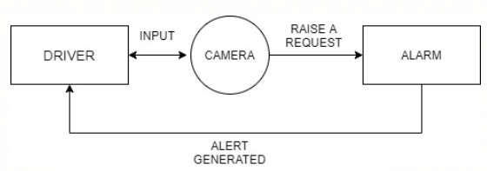

**DFD Level 1:**

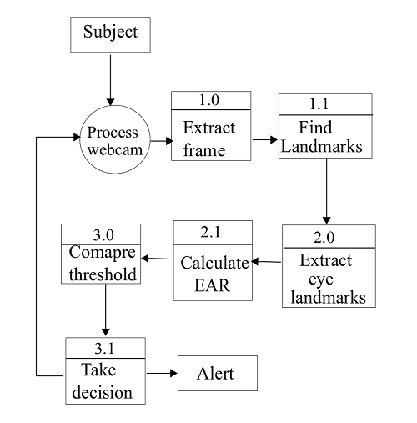

**ENTITY RELATIONSHIP (ER) DIAGRAM:**

–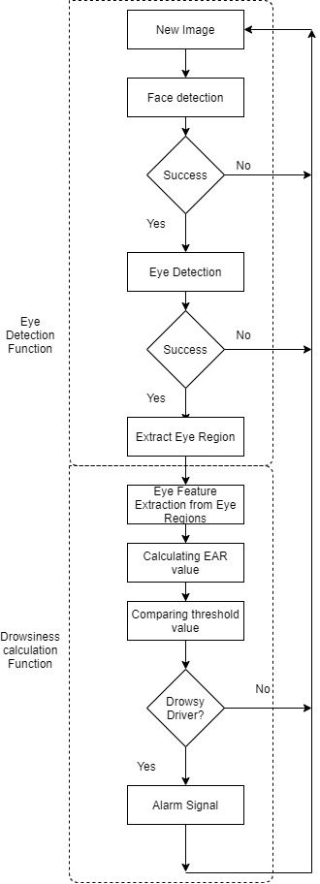

**Hardware Specifications:**

Hardware Specification System: 2 Ghz or faster processor or MacBook

Hard Disk: 16 GB for 32-bit OS 20 GB for 64-bit

Display: 800 x 600

Ram: 4 GB or more for both 32-bit & 64-bit

**Software Specifications:**

Python, OpenCV, TensorFlow

**References and Bibliography:**

* <http://www.ee.ryerson.ca/~phiscock/thesis/drowsy-detector/drowsy-detector.pdf>
* <http://www.cnblogs.com/skyseraph/archive/2011/02/24/1963765.html>
* <http://www.scribd.com/doc/15491045/Learning-OpenCV-Computer-Vision-with-the-OpenCV-Library>
* <http://opencv.willowgarage.com/documentation/reading_and_writing_images_and_video.html>
* <http://www.scribd.com/doc/46566105/opencv>
* Learning OpenCV by Gary Bradski and Adrian Kaehler
* <http://note.sonots.com/SciSoftware/haartraining.html>
* W. Zhao, R. Chellappa, P.J. Phillips, and A. Rosenfeld, “Face Recognition: A Literature Survey,” ACM Computing Surveys, vol. 35, pp. 399-459, 2003.
* M. H. Yang, D. J. Kriegman, and N. Ahuja, “Detecting faces in images: A survey,” IEEE Trans. Pattern Anal. Mach. Intell., vol.24, no.1, , Jan. 2002, pp. 34–58.
* Nan-Ning Zheng, Shuming Tang, Hong Cheng and Qing Li, Guanpi Lai and Fei-Yue Wang,” Toward Intelligent Driver-Assistance and Safety Warning Systems”, Intelligent Transportation System, IEEE 2004.
* Christian Scharfenberger, Samarjit Chakraborty, John Zelek and David Clausi”, Anti-Trap Protection for an Intelligent Smart Car Door System”, 15th International IEEE Conference on Intelligent Transportation System, Anchorage, Alaska, USA, September 16-19, 2012.
* K. C. Yowand, R. Cipolla, “Feature-based human face detection, “Image Vision Comput., vol.15, no.9, 1997, pp.713–735.
* An Analysis of Viola Jones algorithm for face detection by Yi-Quin Wang, University of Malaysia Phang, 2014, pp: 15-20.
* Implementation of Voila Jones Algorithm by Ole Helvig Jensen, university of Denmark, 2008, pp: 20-36.